Review Article :
Implant Microsurgery Techniques - An Overview
¹Dr Ami Patel, ²Dr Neeta Bhavsar, ³Dr Mahesh Chavda, ⁴Dr Sakshee Trivedi, ⁵Dr Kirti Dulani

Department of Periodontology , Govt.Dental College and Hospital Ahmedabad, Gujarat
Corresponding author: Dr Neeta Bhavsar

Abstract:
Microsurgery refers to a surgical procedure performed under a microscope.It is a practice that embraces three distinct values,they are enhancement of motor skills to improve surgical ability, decreased tissue trauma at the surgical site which is achieved with the use of small surgical instruments and a reduced surgical field, application of microsurgical principles to achieve passive and primary wound closure.Implant placement through microsurgery results in immediateaesthetic improvement,faster healing and negligible post operative discomfort to the patient.The purpose of this article is to overview benefits, applications of microsurgery techniques inimplantology.
Keywords:Microsurgery, implant,sinus

Introduction:
Microsurgery refers to a surgical procedure performed under a microscope.It is a practice that embraces three distinct values,they are enhancement of motor skills to improve surgical ability, decreased tissue trauma at the surgical site which is achieved with the use of small surgical instruments and a reduced surgical field, application of microsurgical principles to achieve passive and primary wound closure.¹ Magnification and microsurgical techniques can be used at different stages of treatment with implants (at placement, peri implant plastic surgery, and peri implant management) with greater precision and predictability.^{2,3} For restoring failed maxillary anterior teeth, tapered implants have been exceptionally predictable and highly successful⁴and haveundergoneseveralbiologic, technologic, and restorative advances in recent years⁵, this convergence of clinical research with restorative experience have favored immediate dental implant placement for restoration of a failing maxillary anterior tooth.^{6,7}Furthermore, immediate provisionalization of single-tooth dental implants has been shown to be a viable treatment.^{8,9}However, immediate implant placement and provisionalization present clinical difficulties when performed macrosurgically as opposed to microsurgically. The differences include impaired visualisation, greater trauma, less precision in tooth removal, a poorly lit and often bloody field, incorrect implant placement and angulation, difficulty with contours and soft tissue support associated with immediate provisionalization, incorrect emergence profile, and poor aesthetics.
Techniques:
Different stages of implant treatment ranging from implant placement to implant recovery and peri-implantitis management may be accomplished with more precision under magnification.¹¹One of the novel applications of microsurgery is in immediate implant placement with provisional restoration (SMILE technique).The microsurgical SMILE (Simplified Microsurgical Implant Lifelike Esthetic) technique offers several advantages:
(1) precision of the surgical procedure and enhanced motor skills; (2) reduced tissue trauma with little to no prolonged bleeding; (3) excellent surgical field illumination; (4) precision in implant site preparation; (5) precision with provisional crown fabrication; and (6) passive wound closure with exact primary apposition of the wound edges.^{11,12,13}
The second technique is the sinus lift procedure with a success rate of 97%.^{14,15}The surgical microscope can aid indirect visualization of the sinus membrane and minimizes the risk of perforations. Incorporation of microsurgical techniques for an improvement of altered sensation due to implants encroaching on the inferior alveolar nerve even without unscrewing them has also been reported¹⁶
SMILE (Simplified Microsurgical Implant Lifelike Esthetic):
The SMILE technique was developed to address drawbacks of conventional immediate implant therapy and prevent the potential esthetic compromise by incorporating microsurgical precision. The advantages of the SMILE technique include an extremely high success rate, excellent immediate esthetics and patient acceptance, and a definitive restoration that is fabricated by replicating the provisional emergence profile.

Step-by-step procedure for the SMILE technique developed by Dennis A. Shanelec:¹⁷

Note that all procedures are performed under the operative microscope at a magnification of 10× to 20×

1. Before any surgery is performed, take a clear silicone impression of the failing tooth. This will be used later to fabricate the provisional restoration for the implant.
2. Atraumatically extract the tooth, avoiding buccal and lingual flaps.
3. Deepithelialize the former gingival sulcus.
4. Completely debride the socket under the microscope, eliminating any lateral and apical granulation tissue.
5. Irrigate the socket with 3% tetracycline solution for 30 seconds.
6. Use lateral side cutting drills to align the osteotomy to the palatal wall of the socket.
7. Use an implant that is 4 mm in diameter and 15 to 18 mm long with a standard platform, external hex, and 2-degree tapered surface texture.
8. Position the implant apex lingually to tip the implant platform buccally 2 mm.
9. Position the implant platform 5 mm below the mesial and distal papillae.
10. Position the lingual aspect of the platform at the palatal crest of the socket.
11. Place the implant with at least 67 Ncm torque.
12. Create an opaqued provisional screw-retained titanium abutment substructure.
13. Using the silicone impression taken prior to tooth extraction, create a flowable composite shell crown (or crown former) that replicates the anatomy of the failing tooth.
14. Lute the shell crown to the opaqued abutment in the mouth.
15. Eliminate the flash and fill the subgingival contours with flowable composite.
16. Create and check the emergence profile to support but not distort the buccal tissue and the papillae.
17. Take an impression of the gingival half of the provisional restoration attached to an implant analog.
18. Highly polish and glaze the provisional restoration.
19. Light cure the provisional restoration with a high intensity xenon light to eliminate free monomer.
20. Create a custom impression transfer coping.
21. Fill the buccal socket gap with osseous xenograft to the level of the implant platform.
22. Compress the surface xenograft 1 to 2 minutes to create a fine powdered xenograft seal.
23. Place an autograft filtered from the drilled bone dust and compress it to the platform level.
24. Mold a collagen membrane freeform over the autograft.
25. Create a buccal envelope split-thickness flap through the former buccal sulcus.
26. Harvest a connective tissue graft from the palate and place it into the buccal envelope.
27. After freeing the papillae, advance the flap with 6-0 polypropylene sutures as needed.
28. Check and adjust the occlusion on the palatal aspect of the provisional crown, leaving 1 mm of free space between the crown and the occluding tooth.
29. Fill the screw space inside the implant with metronidazole gel.
30. After installing the provisional restoration with the proper torque, place polytetrafluoroethylene tape above the screw head and seal the access with composite.
31. Perform a postoperative evaluation at 2 and 6 weeks.
32. Proceed to definitive restoration after 8 weeks.
33. Restore with a custom impression coping and scanned zirconia abutment

Dennis A. Shanelec performed the SMILE technique on 300 consecutive patients who required extraction of maxillary central incisors, lateral incisors, or canines, 298 implants resulted in successful functional and esthetic outcomes after 1 to 10 years. No exclusion criteria were used. Of the 300 patients, one patient was lost to follow-up after the implant and provisional restoration were placed, and two implants failed to integrate. Based on radiographic and clinical examination, 298 implants were cleared for definitive restoration at 8 weeks. Patient scheduling and restorative logistics determined restoration delivery to be from 10 to 22 weeks.¹⁷

Success parameters of the SMILE technique:
-Absence of inflammation, infection, mobility, pain, or bleeding on probing
-Implant torque with more than 65 Ncm without rotational movement
-Peri-implant sulcus less than 1 mm apical to the implant platform
-Radiographic evidence of bone tissue formation up to the most coronal thread of the implant
-Definitive restoration and its permanence in function
^{-Satisfactory esthetics}

Steiner’s sinus lift technique:
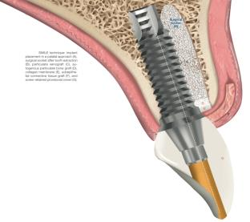
The Steiner Sinus Lift and the sinus lift pioneered by Tatum and described in detail by Misch is comparable in that both methods use a lateral wall osteotomy for graft placement.^{19,20}The differences between the two methods are based primarily on the fact that the Steiner Sinus Lift is minimally invasive while using micro- surgical instrumentation and hydraulic pressure to lift the sinus membrane. The soft tissue flap for the Tatam sinus lift exposes the lateral wall of the maxilla and a portion of the zygoma. The soft tissue flap for the Steiner Sinus Lift is reflected only to the base of the enlarged sinus. Most cases require exposure of the alveolar ridge only in the area of the lowest point of the sinus.
The Tatum method utilizes an osteotomy of approximately 10×15 millimeters,²⁰ and the Steiner Sinus Lift utilizes an osteotomy close to the alveolar ridge of approximately 3 mm in diameter. This difference is more than just less invasive. Retaining the lateral wall of the maxilla preserves more regenerative tissue. Bone regeneration in the maxillary sinus has been found to originate primarily from the surrounding bone and not from the elevated sinus membrane or the periosteum covering the osteotomy.²¹ Preserving the lateral wall of the maxillary sinus preserves this tissue to facilitate bone regeneration. Surgical cuts made through the maxilla to reach the sinus membrane and fracturing in the lateral wall or surgically removing the lateral wall increase the potential for sinus membrane perforation.^{22,23} Following elevation of the sinus membrane using the Tatum sinus lift, it is common practice to routinely place a resorbable membrane soaked with antibiotics below the elevated sinus membrane. In addition, the graft material used for the Tatum sinus lift often includes ceramic granules mixed with antogenous bone harvested from the tuberosity and wetted with an antibiotic solution.¹⁸ The ceramic granules are needed to maintain the graft shape, but they also delay bone regeneration and reduce the amount of bone in contact with implants placed before the granules are resorbed. Antibiotics are required because of the extent of the surgical wound in an environment that cannot be kept sterile.
The graft material used in the Steiner Sinus Lift is a dual-phase calcium phosphate biocement and does not require granules, membranes, or locally applied antibiotics. The graft material sets hard in the maxillary sinus and bonds to the implants. The graft material is completely resorbed in 3 months. The minimal osteotomy, the short time required to perform the surgery, and the placement of the graft material via a sterile syringe makes the Steiner Sinus Lift a potentially sterile technique. Normal sinuses are sterile, and any postoperative sinus infection can originate only from organisms introduced at the time of surgery.
Surgical procedure by Steiner et al:
To perform the subantral sinus augmentation, a crestal incision was made to accommodate implant placement and to expose the buccal alveolar ridge of the maxilla to the lowest point of the maxillary sinus.
A No. 8 round bur in a high-speed handpiece was used to perforate the lateral wall of the maxillary sinus at the lowest point of the sinus. As the internal wall of the sinus was approached, the dark sinus was easily noted before perforation into the sinus.
The osteotomy is commonly between 3 and 4 millimeters in diameter and between 2 and 3 millimeters in depth.
A 1 mm micropaddle (Steiner Laboratories) was pressed onto the osteoid-like layer of the sinus membrane and was slipped between the membrane and the bone. The micropaddle was held in contact with bone as the membrane was released a few millimeters around the circumference of the osteotomy.
When the initial dissection of the membrane around the circumference of the osteotomy was complete, the sinus was entered with a microball (Steiner Laboratories).
Contact with bone was maintained as the membrane was dissected off the floor of the sinus until the medial wall of the sinus was reached. The membrane was dissected mesial and distal to the osteotomy as needed.
As the graft material is injected, the sinus membrane rises under hydraulic pressure. The tip of the syringe is cut to develop a diameter that seals the osteotomy orifice. The syringe tip is manipulated to limit the amount of graft material that leaks between the maxilla and the syringe tip as it is injected. The amount of sinus lift is determined by the amount of graft material injected.
With this technique, implants should be placed at the time of sinus grafting.

Subantral sinus augmentation has proved to be a successful method of providing adequate bone for dental implants in the atrophic maxillae.¹⁷This surgical technique, which allows the sinus to be entered at its lowest point through a 3 to 4 mm osteotomy, significantly reduces surgical trauma. The lift of the sinus membrane with hydraulic pressure while the graft material is injected helps to avoid membrane tears. Bonding of the graft material to the implant stabilizes the implant and facilitates implant integration.^{19,20,21}
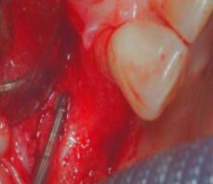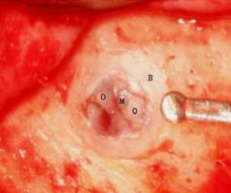
A #8 round bur used to prepare osteotomy O:Osteoid-like bone lining, M:Sinus membrane
B:Bone (the osteotomy is 3-4mm in diameter and 2-3mm deep
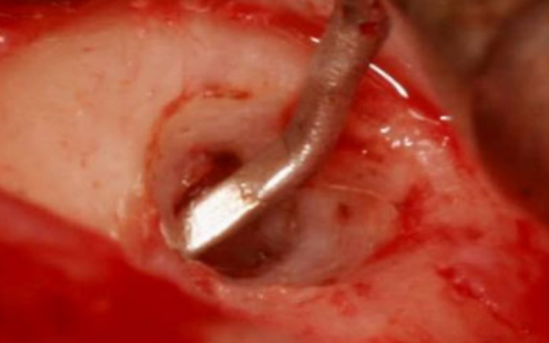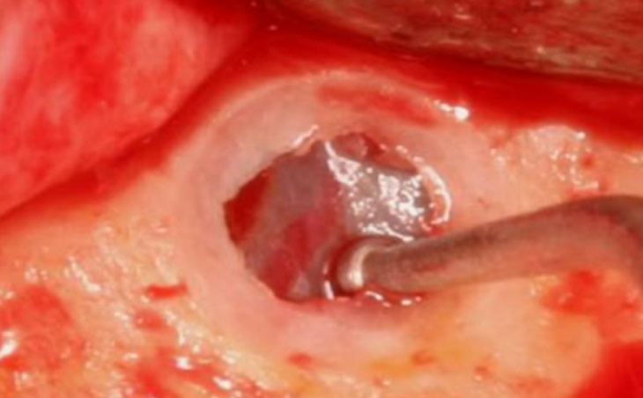
1mm micropaddle is used to release membrane Membrane is dissected off the sinus floor using microball

Advantages of the Steiner Sinus Lift include the following:
- The procedure is minimally invasive.
- The osteotomy is minimal, being 1 to 3 mm deep and 3 to 4 mm wide.
- The dark sinus can be visualized easily before the membrane is reached.
- The membrane is easily visualized, ensuring detachment without damage.
- The amount of lift is determined by the volume of graft injected.
- Lifting the membrane with hydraulic pressure prevents membrane damage.
- The graft material sets hard and supports implants placed in minimal bone.
-The graft material bonds to the implant and the sinus bone, facilitating integration.
- The graft material stimulates osteogenesis and is quickly resorbed.
- Minimal instrumentation with closed grafting permits a sterile technique.
- Implants are placed at the time of sinus grafting.
- Implants are restored 3 months after grafting.
- The simplicity of the procedure requires less time and expertise.
- Cost-effective graft materials reduce cost to the patient.

Conclusion & Future Perspectives:
Intricate detail and small scale of the work is made possible by the surgical microscope.Microsurgical principles also have application in more extensive periodontal surgical procedures, including resective microsurgery and regenerative procedures,extractions and ridge preservation procedures,sinus augmentation & repairs,biopsies and large sift tissue transfers.Appropriately designed and sized microsurgical instruments produce minimal tissue trauma and prompt healing.Tissue should be handled gently and as little as possible.Dentistry will see increasing use of the microscope in many phases of practice, including implant placement and restoration.Microscopy has the potential to advance dentistry from an era of traumatic tooth loss to one of exact and seamless replacement of a failing tooth. Although the technique described is multifaceted and requires many steps to complete successfully, the clinical benefits are outstanding. Successful treatment requires microscope magnification, attention to detail, and a combination of microsurgical and restorative skills.

References:
1-Tibbetts LS, Shanelec D. Periodontal microsurgery. Dent Clin North Am 1998;42:339-359.
2-Engelke W, Schwarzwäller W, Behnsen A, Jacobs HG. Subantro- scopiclaterobasal sinus floor augmentation (SALSA): An up-to-5- year clinical study. Int J Oral Maxillofac Implants 2003;18:135–143. 57.
3- Steiner GG, Steiner DM, Herbias MP, Steiner R. Minimally invasive sinus augmentation. J Oral Implantol 2010;36:295–304.
4-Adell R, Eriksson B, Lekholm U, Brånemark PI, Jemt T. Long-term follow-up study of osseointegrated implants in the treatment of to- tally edentulous jaws. Int J Oral Maxillofac Implants 1990;5:347–359.
5-Widmark G, Friberg B, Johansson B, Sindet-Pedersen S, Taylor A. Mk III: A third generation of the self-tapping Brånemark System implant, including the new Stargrip internal grip design. A 1-year prospective four-center study. Clin Implant Dent Relat Res 2003;5:273–279.
6-Covani U, Crespi R, Cornelini R, Barone A. Immediate implants supporting single crown restoration: A 4-year prospective study. J Periodontol2004;75:982–988.
7-Evian CT, Emling R, Rosenberg ES, et al. Retrospective analysis of implant survival and the influence of periodontal disease and imme- diate placement on long-term results. Int J Oral Maxillofac Implants 2004;19:393–398.
8-Hui E, Chow J, Li D, Liu J, Wat P, Law H. Immediate provisional for single-tooth implant replacement with Brånemark System: Prelimi- nary report. Clin Implant Dent Relat Res 2001;3:79–86.
9-Degidi M, Piattelli A. Immediate functional and non-functional load- ing of dental implants: A 2- to 60-month follow-up study of 646 ti- tanium implants. J Periodontol2003;74:225–241.
10-Romanos GE. Present status of immediate loading of oral implants. J Oral Implantol2004;30:189–197.
11- Tibbetts LS, Shanelec D. Periodontal microsurgery. Dent Clin North Am 1998;42:339–359.
12- Tibbetts LS, Shanelec DA. A review of the principles and practice of periodontal microsurgery. Tex Dent J 2007;124:188–204.
13- Tibbetts LS, Shanelec D. Principles and practice of periodontal microsurgery. Int J Microdent2009;1:13–24.
14-Steiner GG, Steiner DM, Herbias MP, Steiner R. Minimally invasive sinus augmentation. J Oral Implantol 2010;36:295-304.
15-Engelke W, Schwarzwäller W, Behnsen A, Jacobs HG. Subantroscopiclaterobasal sinus floor augmentation (SALSA): An up-to-5-year clinical study. Int J Oral Maxillofac Implants
2003;18:135-43.
16-Gennaro P, Chisci G, Gabriele G, Iannetti G. Conservative surgical
and microsurgical techniques for the management of dental implants that impinge on the inferior alveolar nerve. Br J Oral Maxillofac Surg2014;52:566-8.
17-Shanelec, D.A. and Tibbetts, L.S. (2011), Implant Microsurgery: Immediate Implant Placement With Implant-Supported Provisional. Clinical Advances in Periodontics, 1: 161-172.
18-Shanelec D, Tibbetts L. Recent advances in surgical technology. In: Newman MG, Takei HH, Carranza FA (eds). Clinical Periodontology, ed 9. Philadephia: Saunders, 2009:876–881.
19-Tatum OH. Maxillary and sinus implant recon- struction. Dent Clin North Am. 1986;30:107–119.
20-Misch CE. Contemporary Implant Dentistry. 3rd ed. St. Louis: Mosby Elsevier; 2009.
21- Vlassis JM, Hurzeler MB, Quinones CR. Sinus lift augmentation to facilitate placement of nonsub- merged implants: a clinical and histological report. Pract Periodontics Aesthet Dent. 1993;5:15–23.
22- Becker ST, Terheyden H, Steinriede A, Behrens E, Springer I, Wiltfang J. Prospective observation of 41 perforations of the Schneiderian membrane during sinus floor elevation. Clin Oral Implants Res. 2008;19: 1285–1289.
23-Herna ́ndez-Alfaro F, Torradeflot MM, Marti C. Prevalence and management of Schneiderian mem- brane perforations during sinus-lift procedures. Clin Oral Implants Res. 2008;19:91–98.

